
Safety Bay Senior High School
Name: __________________________________
Year 11 Physics 2021
Test 1: Heating Processes
Weighting 6%

Total Marks: 46 Time Allowed: 50 minutes

Question 1 (3 marks)

Explain why, inside a refrigerator, the food temperature decreases but the refrigerant temperature does not increase.

Question 2 (3 marks)

To what Celsius temperature must a 50.0°C iron bar be heated in order that its absolute temperature increases by 10.0%?

Question 3 (6 marks)

Charis heats up a saucepan of water on an electric hotplate.

- Why will the heating be more efficient if Charis places a lid on the saucepan? [1]

Suppose that the heating process is 90.0% efficient with the lid on and that the hotplate supplies heat at the rate of 2.40 kJ s⁻¹.

- How many minutes will it take Charis to heat 1.80 litres of water (with the lid on) from 24.0°C to 85.0°C? [5]

Question 4 (10 marks)

To make an ice bath used to soothe sporting injuries, ice at $-$5.00°C is added to 127 litres of tap water at 23.0°C. (Ignore heat loss to the surroundings in this question.)

- How much ice must be added if the final temperature of the mixture is to be 8.00°C? [4]

- How much ice must be added if the entire bath is to be water at 0.00°C? [4]

- If, instead, ice at 0.00°C had been added, why would it be impossible to turn the entire bath into ice at 0.00°C, no matter how much ice were added? [2]

Question 5 (7 marks)

A jeweller is creating a sterling silver chest that weighs 2.00kg. To create the box the jeweller has to heat room temperature (25⁰C) sterling silver till it melts. The energy required to bring the sterling silver to its melting point is 4.59 x 10⁵J. If the specific heat capacity of the sterling silver is 245 J/kgK, calculate the melting point of the silver. [4]

Calculate the total amount of energy required to completely melt the sterling silver from room temperature, given the latent heat of vaporization of sterling silver is 1.05 x 10⁵J/kg. [3]

Question 6 (9 marks)

Scientists found an unknown specimen. In order to determine what the substance was they applied a constant heat to it and recorded the change in temperature. The specimen weighed 46.7kg.
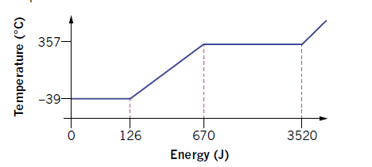
Energy (kJ)
Liquid
Gas
Using the information from the graph calculate the specific heat capacity of the unknown substance. [3]

What is the latent heat of vaporisation of the specimen. [3]

If heat was supplied to the specimen at a rate of 0.6 MJ/s, calculate the amount of time required for the specimen to change from a liquid to a gas. [3]

Question 7 (2 marks)

It’s summer in Australia and you are sitting in the shade under a tree. Explain why it is better for you to be wearing a black shirt instead of a white shirt.

Question 8 (6 marks)

List three energy efficient housing designs and explain how they keep the house cool in the summer and warm in the winter.

-End of Questions-

